**BANK LOAN REPORT QUERY DOCUMENT**

1. **BANK LOAN REPORT | SUMMARY**

**KPI’s:**

**Total Loan Applications**

SELECT count(id) As Total_loan_applications FROM loandb.financial_loan;

**MTD Loan Applications**

SELECT COUNT(id) AS MTD_Total_Applications

FROM loandb.financial_loan

WHERE MONTH(STR_TO_DATE(issue_date, '%Y-%m-%d')) = 12;



**PMTD Loan Applications**  
SELECT COUNT(id) AS PMTD_Total_Applications

FROM loandb.financial_loan

WHERE MONTH(STR_TO_DATE(issue_date, '%Y-%m-%d')) = 11;



**Total Funded Amount**

SELECT SUM(loan_amount) AS Total_Funded_Amount FROM loandb.financial_loan



**MTD Total Funded Amount**

SELECT sum(loan_amount) AS MTD_Funded_Amount

FROM loandb.financial_loan

WHERE MONTH(STR_TO_DATE(issue_date, '%Y-%m-%d')) = 12;



**PMTD Total Funded Amount**

SELECT sum(loan_amount) AS MTD_Funded_Amount

FROM loandb.financial_loan

WHERE MONTH(STR_TO_DATE(issue_date, '%Y-%m-%d')) = 11;



**Total Amount Received**

SELECT SUM(total_payment) AS Total_Amount_Collected FROM loandb.financial_loan



**MTD Total Amount Received**

SELECT SUM(total_payment) AS Total_Amount_Collected FROM loandb.financial_loan

WHERE MONTH(issue_date) = 12



**PMTD Total Amount Received**

SELECT SUM(total_payment) AS Total_Amount_Collected FROM loandb.financial_loan

WHERE MONTH(issue_date) = 11



**Average Interest Rate**

SELECT AVG(int_rate)*100 AS Avg_Int_Rate FROM bank_loan_data



**MTD Average Interest**

SELECT AVG(int_rate)*100 AS MTD_Avg_Int_Rate FROM bank_loan_data

WHERE MONTH(issue_date) = 12



**PMTD Average Interest**

SELECT AVG(int_rate)*100 AS PMTD_Avg_Int_Rate FROM bank_loan_data

WHERE MONTH(issue_date) = 11



**Avg DTI**

SELECT AVG(dti)*100 AS Avg_DTI FROM loandb.financial_loan



**MTD Avg DTI**

SELECT AVG(dti)*100 AS MTD_Avg_DTI FROM loandb.financial_loan WHERE MONTH(issue_date) = 12



**PMTD Avg DTI**

SELECT AVG(dti)*100 AS PMTD_Avg_DTI FROM loandb.financial_loan

WHERE MONTH(issue_date) = 11



**GOOD LOAN ISSUED**

**Good Loan issued Percentage**

SELECT (count(case when loan_status="Fully Paid" or loan_status="Current" then id end)*100)/count(id) as Good_Loan_Percentage from loandb.financial_loan;****

**Good Loan Applications**

SELECT count(case when loan_status="Fully Paid" or loan_status="Current" then id end) as Good_Loan_Applications from loandb.financial_loan;



**Good Loan Funded Amount**

SELECT sum(case when loan_status="Fully Paid" or loan_status="Current" then loan_amount end) as Good_Loan_Funded_amount from loandb.financial_loan;



**Good Loan Amount Received**

SELECT sum(case when loan_status="Fully Paid" or loan_status="Current" then total_payment end) as Good_Loan_amount_received from loandb.financial_loan;



**BAD LOAN ISSUED**

**Bad Loan Percentage**

SELECT (count(case when loan_status="Charged Off" then id end)*100)/count(id) as Bad_Loan_percentage from loandb.financial_loan;



**Bad Loan Applications**

SELECT count(case when loan_status="Charged Off" then id end) as Bad_Loan_Applications from loandb.financial_loan;



**Bad Loan Funded Amount**

SELECT sum(case when loan_status="Charged Off" then loan_amount end) as Bad_Loan_Funded_amount from loandb.financial_loan;



**Bad Loan Amount Received**

SELECT sum(case when loan_status="Charged Off" then total_payment end) as Bad_Loan_amount_Received from loandb.financial_loan;



**LOAN STATUS**

SELECT

loan_status,

COUNT(id) AS LoanCount,

SUM(total_payment) AS Total_Amount_Received,

SUM(loan_amount) AS Total_Funded_Amount,

AVG(int_rate * 100) AS Interest_Rate,

AVG(dti * 100) AS DTI

FROM

loandb.financial_loan

GROUP BY

loan_status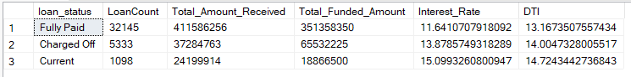

SELECT

loan_status,

SUM(total_payment) AS MTD_Total_Amount_Received,

SUM(loan_amount) AS MTD_Total_Funded_Amount

FROM bank_loan_data

WHERE MONTH(issue_date) = 12

GROUP BY loan_status

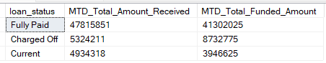

1. **BANK LOAN REPORT | OVERVIEW**

**MONTH**

select

month(str_to_date(issue_date,'%Y-%m-%d')) as month_number,

date_format(str_to_date(issue_date,'%Y-%m-%d'),'%m') as month_name,

count(id) as Total_Loan_Application,

sum(loan_amount) as Total_Funded_Amount,

sum(total_payment) as Total_Amount_Received

FROM

loandb.financial_loan

group by month_number ,month_name

order by month_name

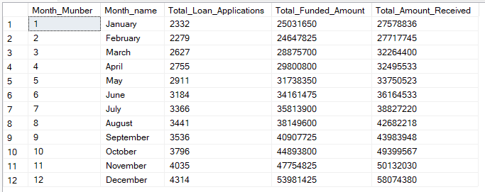

**STATE**

SELECT address_state,count(id) as Totl_Loan_Applications,

sum(loan_amount) as Total_Funded_Amount,

sum(total_payment) as Total_Amount_recieved

FROM loandb.financial_loan

group by address_state

order by address_state

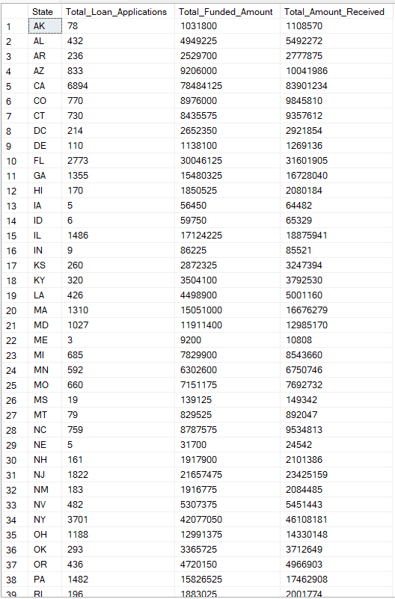

**TERM**

SELECT Term,count(id) as Total_Loan_Applications,

sum(loan_amount) as Total_Funded_Amount,

sum(total_payment) as Total_Amount_recieved

FROM loandb.financial_loan

group by Term

order by Term

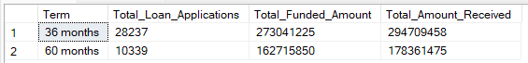

**EMPLOYEE LENGTH**

SELECT emp_length,count(id) as Total_Loan_Applications,

sum(loan_amount) as Total_Funded_Amount,

sum(total_payment) as Total_Amount_recieved

FROM loandb.financial_loan

group by emp_length

order by emp_length 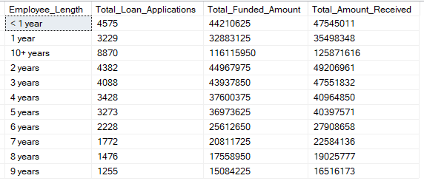

**PURPOSE**

SELECT purpose,count(id) as Total_Loan_Applications,

sum(loan_amount) as Total_Funded_Amount,

sum(total_payment) as Total_Amount_recieved

FROM loandb.financial_loan

group by purpose

order by purpose

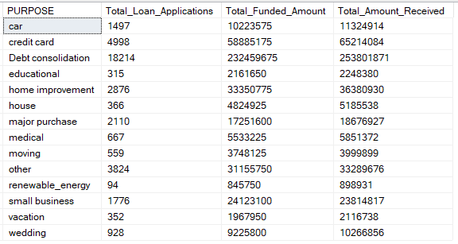

**HOME OWNERSHIP**

SELECT home_ownership,count(id) as Total_Loan_Applications,

sum(loan_amount) as Total_Funded_Amount,

sum(total_payment) as Total_Amount_recieved

FROM loandb.financial_loan

group by home_ownership

order by home_ownership